Duwamish Hill Saturday OCT 19, 2019

To be fair the weather prediction was not calling for good weather. It was calling for drizzle and rain showers all day. However, we Seattleites are known for our rain tolerance. So, I showed up in Tukwila as the representative NFA member at Duwamish Hill on the 19th. Other diehards showed up which meant we had enough people for the work party.

It was gratifying to see how much the site had improved since our club first worked on it a few years ago. Instead of an abandoned, trash filled lot, one now sees a small plot that is a wetland. It now acts as a buffer protecting the river. Run off from the surrounding industrial area now gets filtered before ending up in the Duwamish. Before starting we were greeted by a member of the Duwamish People’s Council who thanked the volunteers for all the hard work restoring the Hill. That thank you was seconded by the head of the Tukwila City Council.

Despite what seemed to be endless weeding in the past, invasive trees were establishing themselves again. Surprisingly Cottonwoods springing up on the property were considered to be an invasive species. At least for the purposes of creating a wetland. Armed with weed wrenches we spread out and cleared away the invading saplings.
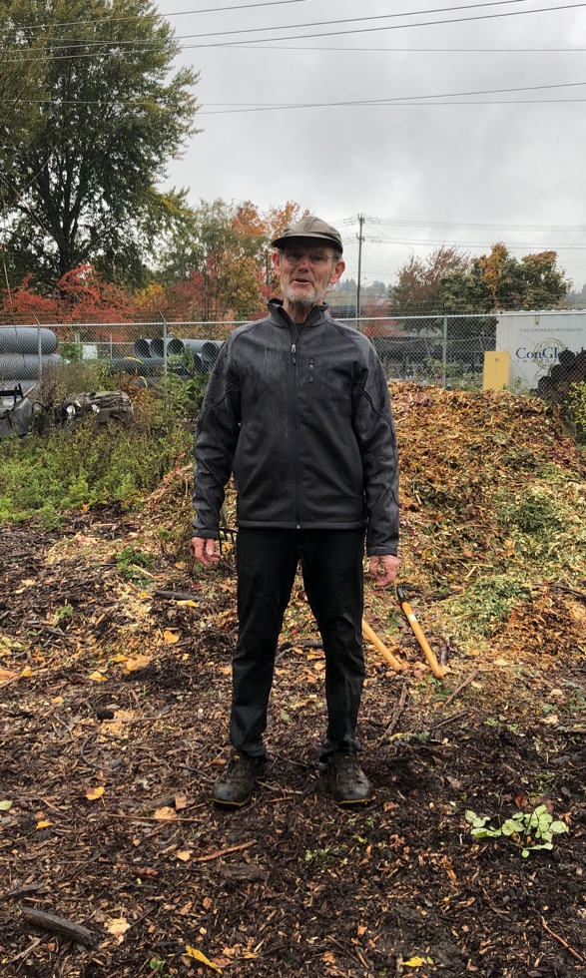
Wytold Lebing 10/19/19
The rain was annoying at first. But it didn’t take long for the group to fall into the “work party groove”. We were joking and laughing as we were slowly getting wet. The work kept us warm. And honestly despite ending up muddy and wet it was rewarding to be helping improve the lot and improving the situation for our endangered salmon.

