Miller and Walker Creeks Stewardship
On Saturday April 27, 2019 three members of NFA showed up in Burien at Walker Woods preserve to clear invasives. The group included Tom Beaulaurier, Carol Johnson, and Wytold Lebing.
The Miller and Walker Creeks Stewardship program monitors and improves the two main streams, Miller and Walker, which drain the northern and western drainage basins adjacent to SeaTac Airport. They join together and empty into the Lower Puget Sound west of SeaTac below Three Tree Point.
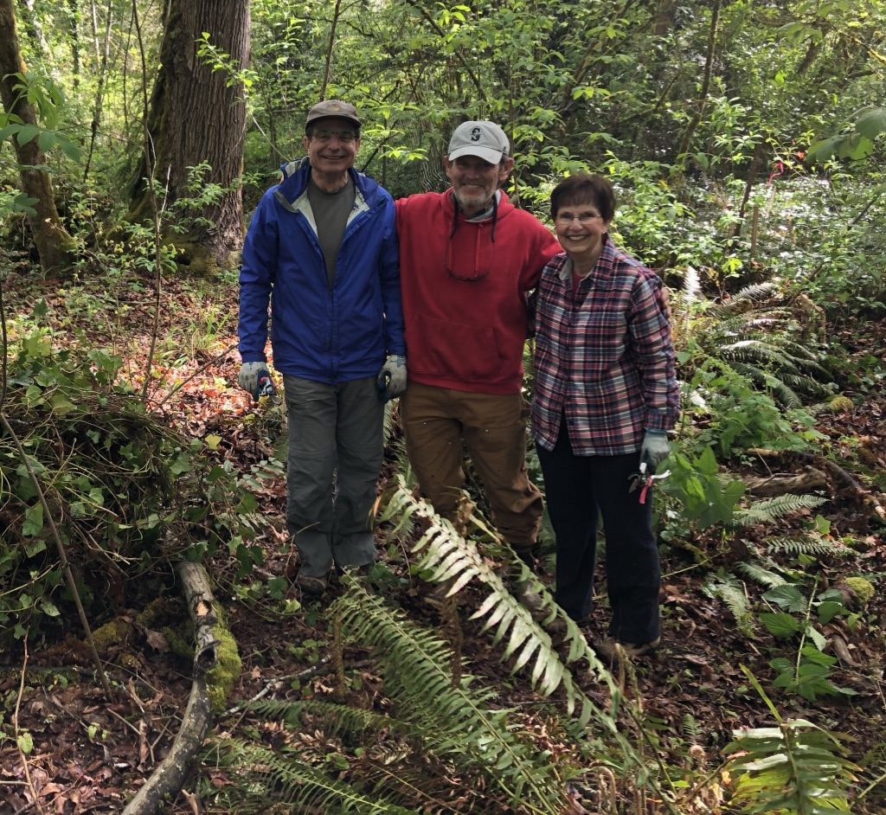
From left to right: T Beaulaurier, Wytold Lebing, Carol Johnson
Restoration work benefits returning Coho and Chum salmon. But the conditions adjacent to these streams are degraded by invasive species. Large rain and run off events can kill Coho and wash out fish redds. Yet somehow these fish maintain an almost miraculous hold in these small creeks
All of us were pleasantly surprised to find a large tract of woods surrounding the streams. This despite the proximity to Seatac and Seattle, this patch of woods winds through Burien and offers some protection for the streams. However, through neglect, ivy and blackberries have invaded the area and are choking out native species. Removal of invasive plants and replanting native species will help to restore the type of stream environment which the coho and chum are looking for.
We certainly pulled our share of ivy that morning which is work. Yet making the woods a little more friendly for fish and plants was the reward we were looking for. It’s always rewarding to feel that you’ve done something to help our struggling salmon populations. And for the three of us there was the added discovery of a new area of woods, complete with a pair of active spawning streams.

